OP3 mass property

all

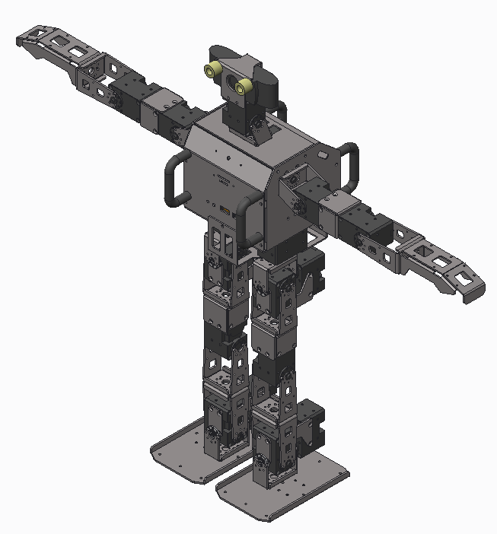

MASS = 3.1407997e+03 GRAM

CENTER OF GRAVITY with respect to BODY coordinate frame:

X Y Z -1.0713078e+01 9.6346662e-02 -4.2954607e+00 MM

INERTIA with respect to BODY coordinate frame: (GRAM * MM^2)

INERTIA TENSOR:

Ixx Ixy Ixz 7.0691839e+07 1.3246208e+04 -9.5473149e+05

Iyx Iyy Iyz 1.3246208e+04 5.7589536e+07 -2.2441172e+04

Izx Izy Izz -9.5473149e+05 -2.2441172e+04 1.8391122e+07

INERTIA at CENTER OF GRAVITY with respect to BODY coordinate frame: (GRAM * MM^2)

INERTIA TENSOR:

Ixx Ixy Ixz 7.0633859e+07 1.0004371e+04 -8.1019940e+05

Iyx Iyy Iyz 1.0004371e+04 5.7171116e+07 -2.3741002e+04

Izx Izy Izz -8.1019940e+05 -2.3741002e+04 1.8030623e+07

body

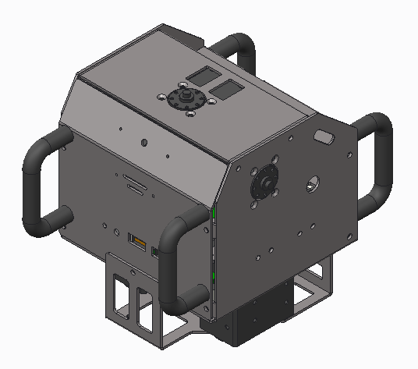

MASS = 1.3492787e+03 GRAM

CENTER OF GRAVITY with respect to BODY coordinate frame:

X Y Z -1.5014868e+01 1.3099003e-01 6.5815797e+01 MM

INERTIA with respect to BODY coordinate frame: (GRAM * MM^2)

INERTIA TENSOR:

Ixx Ixy Ixz 9.2497076e+06 8.3752923e+03 1.2908159e+06

Iyx Iyy Iyz 8.3752923e+03 9.1182732e+06 -1.2226909e+04

Izx Izy Izz 1.2908159e+06 -1.2226909e+04 3.4775256e+06

INERTIA at CENTER OF GRAVITY with respect to BODY coordinate frame: (GRAM * MM^2)

INERTIA TENSOR:

Ixx Ixy Ixz 3.4049880e+06 5.7215338e+03 -4.2562251e+04

Iyx Iyy Iyz 5.7215338e+03 2.9693870e+06 -5.9448930e+02

Izx Izy Izz -4.2562251e+04 -5.9448930e+02 3.1733127e+06

head_01

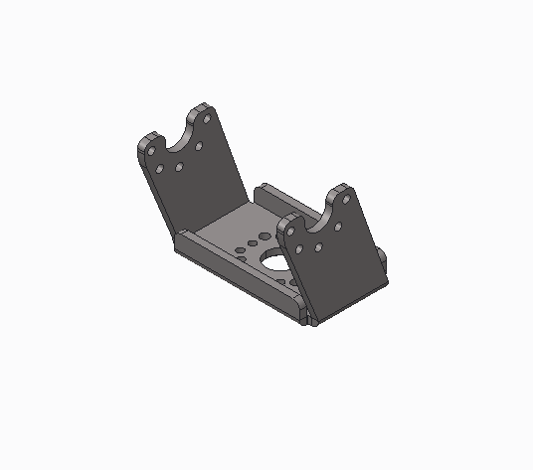

MASS = 1.1759436e+01 GRAM

CENTER OF GRAVITY with respect to HEAD_01 coordinate frame:

X Y Z 2.3274785e+00 0.0000000e+00 8.2278468e+00 MM

INERTIA with respect to HEAD_01 coordinate frame: (GRAM * MM^2)

INERTIA TENSOR:

Ixx Ixy Ixz 4.7653088e+03 0.0000000e+00 -5.3869814e+02

Iyx Iyy Iyz 0.0000000e+00 2.5143008e+03 0.0000000e+00

Izx Izy Izz -5.3869814e+02 0.0000000e+00 3.9287867e+03

INERTIA at CENTER OF GRAVITY with respect to HEAD_01 coordinate frame: (GRAM * MM^2)

INERTIA TENSOR:

Ixx Ixy Ixz 3.9692248e+03 0.0000000e+00 -3.1350333e+02

Iyx Iyy Iyz 0.0000000e+00 1.6545141e+03 0.0000000e+00

Izx Izy Izz -3.1350333e+02 0.0000000e+00 3.8650840e+03

head_02

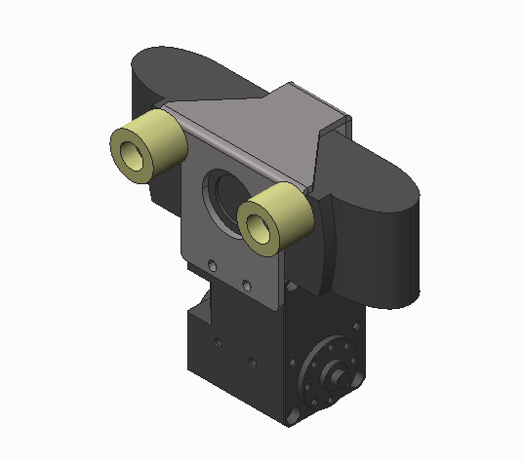

MASS = 1.3630649e+02 GRAM

CENTER OF GRAVITY with respect to HEAD_02 coordinate frame:

X Y Z 2.2984110e+00 -1.8634079e+01 2.7696734e+01 MM

INERTIA with respect to HEAD_02 coordinate frame: (GRAM * MM^2)

INERTIA TENSOR:

Ixx Ixy Ixz 2.5801520e+05 5.9524764e+03 -1.7776647e+04

Iyx Iyy Iyz 5.9524764e+03 1.9249168e+05 7.1188906e+04

Izx Izy Izz -1.7776647e+04 7.1188906e+04 9.3339810e+04

INERTIA at CENTER OF GRAVITY with respect to HEAD_02 coordinate frame: (GRAM * MM^2)

INERTIA TENSOR:

Ixx Ixy Ixz 1.0612371e+05 1.1463684e+02 -9.0995835e+03

Iyx Iyy Iyz 1.1463684e+02 8.7209668e+04 8.4070138e+02

Izx Izy Izz -9.0995835e+03 8.4070138e+02 4.5290192e+04

Larm_01

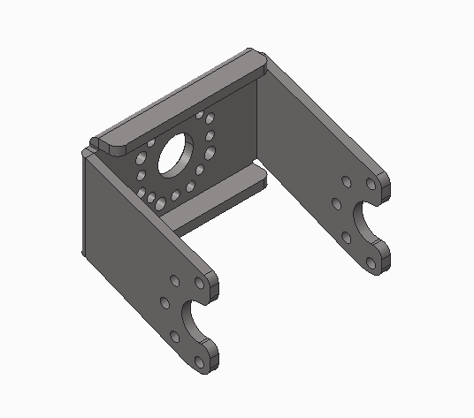

MASS = 1.1759436e+01 GRAM

CENTER OF GRAVITY with respect to LARM_01 coordinate frame:

X Y Z 0.0000000e+00 8.2278468e+00 -2.3274785e+00 MM

INERTIA with respect to LARM_01 coordinate frame: (GRAM * MM^2)

INERTIA TENSOR:

Ixx Ixy Ixz 2.5143008e+03 0.0000000e+00 0.0000000e+00

Iyx Iyy Iyz 0.0000000e+00 3.9287867e+03 5.3869814e+02

Izx Izy Izz 0.0000000e+00 5.3869814e+02 4.7653088e+03

INERTIA at CENTER OF GRAVITY with respect to LARM_01 coordinate frame: (GRAM * MM^2)

INERTIA TENSOR:

Ixx Ixy Ixz 1.6545141e+03 0.0000000e+00 0.0000000e+00

Iyx Iyy Iyz 0.0000000e+00 3.8650840e+03 3.1350333e+02

Izx Izy Izz 0.0000000e+00 3.1350333e+02 3.9692248e+03

Larm_02

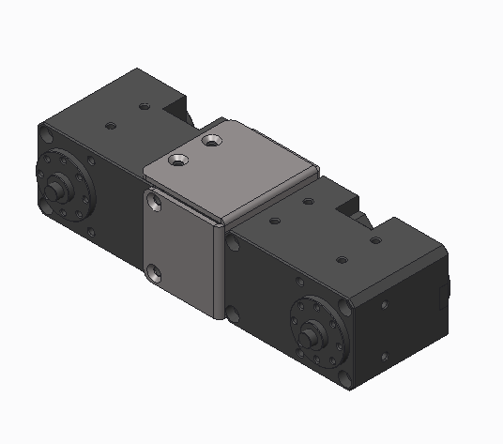

MASS = 1.7757630e+02 GRAM

CENTER OF GRAVITY with respect to LARM_02 coordinate frame:

X Y Z -1.8438243e+01 4.5143767e+01 2.8121245e-01 MM

INERTIA with respect to LARM_02 coordinate frame: (GRAM * MM^2)

INERTIA TENSOR:

Ixx Ixy Ixz 5.8994812e+05 1.4780388e+05 9.5378389e+02

Iyx Iyy Iyz 1.4780388e+05 9.0808093e+04 -1.6674741e+03

Izx Izy Izz 9.5378389e+02 -1.6674741e+03 6.5700529e+05

INERTIA at CENTER OF GRAVITY with respect to LARM_02 coordinate frame: (GRAM * MM^2)

INERTIA TENSOR:

Ixx Ixy Ixz 2.2804074e+05 -5.6090244e+00 3.3039526e+01

Iyx Iyy Iyz -5.6090244e+00 3.0423649e+04 5.8685513e+02

Izx Izy Izz 3.3039526e+01 5.8685513e+02 2.3474154e+05

Larm_03

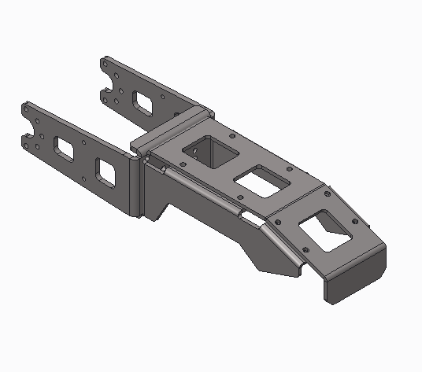

MASS = 4.1267974e+01 GRAM

CENTER OF GRAVITY with respect to LARM_03 coordinate frame:

X Y Z -1.8999997e+01 7.0330391e+01 3.8001172e+00 MM

INERTIA with respect to LARM_03 coordinate frame: (GRAM * MM^2)

INERTIA TENSOR:

Ixx Ixy Ixz 2.6667887e+05 5.5145453e+04 2.9796395e+03

Iyx Iyy Iyz 5.5145453e+04 2.7798745e+04 -1.4746220e+04

Izx Izy Izz 2.9796395e+03 -1.4746220e+04 2.8756814e+05

INERTIA at CENTER OF GRAVITY with respect to LARM_03 coordinate frame: (GRAM * MM^2)

INERTIA TENSOR:

Ixx Ixy Ixz 6.1956503e+04 0.0000000e+00 0.0000000e+00

Iyx Iyy Iyz 0.0000000e+00 1.2305064e+04 -3.7167873e+03

Izx Izy Izz 0.0000000e+00 -3.7167873e+03 6.8543993e+04

Rarm_01

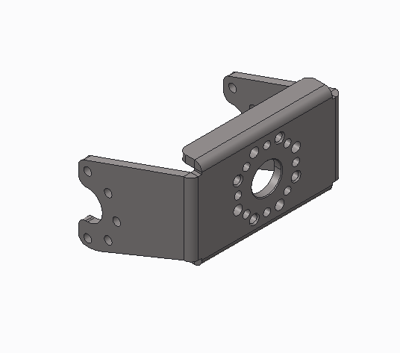

MASS = 1.1759436e+01 GRAM

CENTER OF GRAVITY with respect to RARM_01 coordinate frame:

X Y Z 0.0000000e+00 -8.2278468e+00 -2.3274785e+00 MM

INERTIA with respect to RARM_01 coordinate frame: (GRAM * MM^2)

INERTIA TENSOR:

Ixx Ixy Ixz 2.5143008e+03 0.0000000e+00 0.0000000e+00

Iyx Iyy Iyz 0.0000000e+00 3.9287867e+03 -5.3869814e+02

Izx Izy Izz 0.0000000e+00 -5.3869814e+02 4.7653088e+03

INERTIA at CENTER OF GRAVITY with respect to RARM_01 coordinate frame: (GRAM * MM^2)

INERTIA TENSOR:

Ixx Ixy Ixz 1.6545141e+03 0.0000000e+00 0.0000000e+00

Iyx Iyy Iyz 0.0000000e+00 3.8650840e+03 -3.1350333e+02

Izx Izy Izz 0.0000000e+00 -3.1350333e+02 3.9692248e+03

Rarm_02

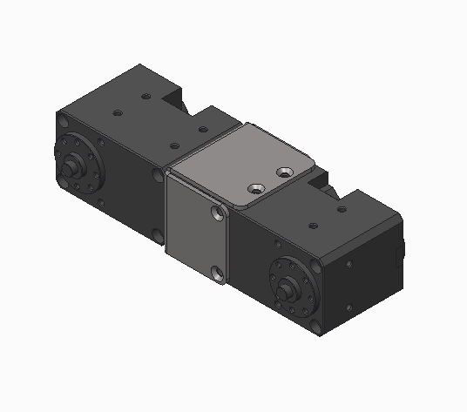

MASS = 1.7757630e+02 GRAM

CENTER OF GRAVITY with respect to RARM_02 coordinate frame:

X Y Z -1.8438243e+01 -4.5143767e+01 2.8121245e-01 MM

INERTIA with respect to RARM_02 coordinate frame: (GRAM * MM^2)

INERTIA TENSOR:

Ixx Ixy Ixz 5.8994812e+05 -1.4780388e+05 9.5378487e+02

Iyx Iyy Iyz -1.4780388e+05 9.0808091e+04 1.6674770e+03

Izx Izy Izz 9.5378487e+02 1.6674770e+03 6.5700528e+05

INERTIA at CENTER OF GRAVITY with respect to RARM_02 coordinate frame: (GRAM * MM^2)

INERTIA TENSOR:

Ixx Ixy Ixz 2.2804074e+05 5.6099519e+00 3.3040526e+01

Iyx Iyy Iyz 5.6099519e+00 3.0423649e+04 -5.8685218e+02

Izx Izy Izz 3.3040526e+01 -5.8685218e+02 2.3474154e+05

Rarm_03

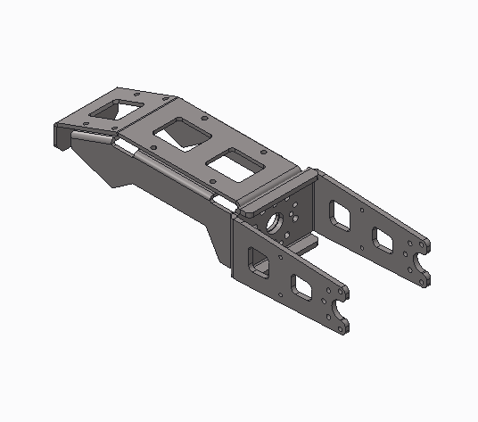

MASS = 4.1267974e+01 GRAM

CENTER OF GRAVITY with respect to RARM_03 coordinate frame:

X Y Z -1.9000003e+01 -7.0330391e+01 3.8001196e+00 MM

INERTIA with respect to RARM_03 coordinate frame: (GRAM * MM^2)

INERTIA TENSOR:

Ixx Ixy Ixz 2.6667887e+05 -5.5145471e+04 2.9796415e+03

Iyx Iyy Iyz -5.5145471e+04 2.7798753e+04 1.4746221e+04

Izx Izy Izz 2.9796415e+03 1.4746221e+04 2.8756815e+05

INERTIA at CENTER OF GRAVITY with respect to RARM_03 coordinate frame: (GRAM * MM^2)

INERTIA TENSOR:

Ixx Ixy Ixz 6.1956503e+04 0.0000000e+00 0.0000000e+00

Iyx Iyy Iyz 0.0000000e+00 1.2305064e+04 3.7167813e+03

Izx Izy Izz 0.0000000e+00 3.7167813e+03 6.8543993e+04

|  |  |  |  |
| --- | --- | --- | --- |
|  | x | y | z |
| Base - head_01 | -1 | 0 | 136.5 |
| Head_01 - head_02 | 10 | 19 | 28.5 |

|  |  |  |  |
| --- | --- | --- | --- |
|  | x | y | z |
| Base - Larm_01 | -1 | 60 | 111 |
| Larm_01 - Larm_02 | 19 | 28.5 | -10 |
| Larm_02 - Larm_03 | 0 | 90.4 | -0.1 |

|  |  |  |  |
| --- | --- | --- | --- |
|  | x | y | z |
| Base - rarm_01 | -1 | -60 | 111 |
| rarm_01 - rarm_02 | 19 | -28.5 | -10 |
| rarm_02 - rarm_03 | 0 | -90.4 | -0.1 |